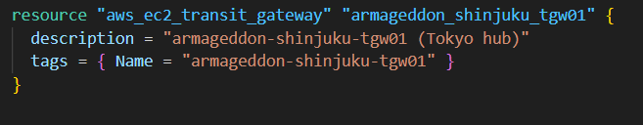
What it creates: a Transit Gateway (TGW) in ap-northeast-1 (Tokyo).
What it’s for: TGW is a regional router that connects multiple networks (VPCs, VPNs, DX, and other TGWs via peering).
Output you use later: aws_ec2_transit_gateway.armageddon_shinjuku_tgw01.id (the TGW ID), plus default route table IDs on that TGW.

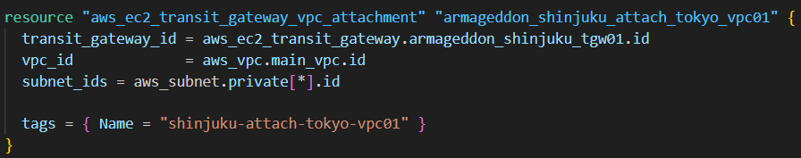
What it creates: a TGW VPC attachment between:
- the Tokyo TGW
- your Tokyo VPC (aws_vpc.main_vpc)
Why the subnet_ids matter: those subnets become the “attachment ENI locations” in your VPC (one per AZ you include).
Important note: Using aws_subnet.private[*].id attaches all private subnets you have. That’s okay if you truly want that, but common practice is 2 subnets in 2 AZs for HA, not necessarily every subnet.

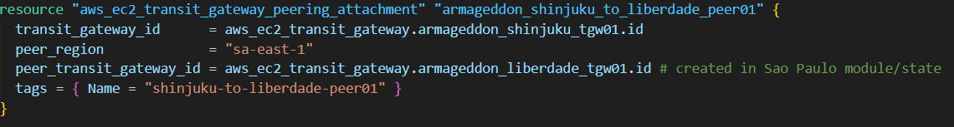
What it creates: a TGW peering attachment request from Tokyo TGW to a São Paulo TGW.
peer_transit_gateway_id: must be the TGW ID in São Paulo. You’re referencing it as if Terraform can “see” it; that’s only true if:
- it’s in the same state, or
- you import it via terraform_remote_state output, or
- you pass it in as a variable.
Missing piece (implied by your later depends_on):
- The accepter resource must exist in São Paulo (aws_ec2_transit_gateway_peering_attachment_accepter) to accept the peering.

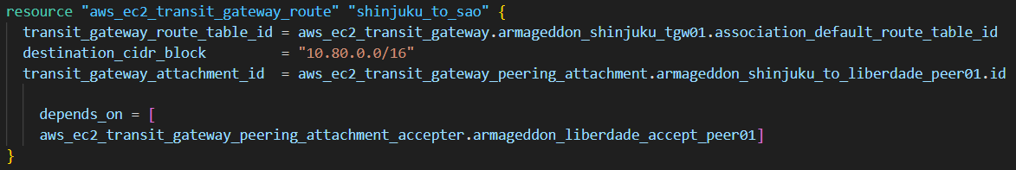
What it does: inside the Tokyo TGW’s default association route table, it says:
- “To reach 10.80.0.0/16 (São Paulo VPC), forward traffic over the TGW peering attachment.”
Why depends_on: Terraform might try to add the route before the peering is accepted. This forces ordering so the accepter exists/ran first.
Key idea: TGW routing is separate from VPC routing. This is the TGW-side route.

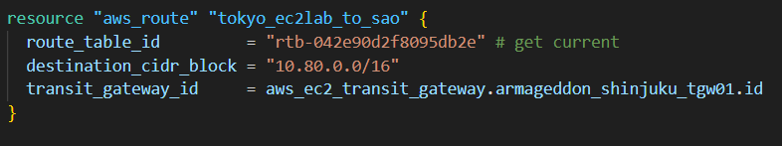
What it does: in one specific Tokyo VPC route table, it says:
- “To reach 10.80.0.0/16, send to the TGW.”
Why this is required: instances in your Tokyo subnets use their subnet’s route table. Without this VPC route:
- traffic destined for São Paulo never even reaches the TGW.
Big red flag: the route table ID is hard-coded. If you ever recreate route tables, that ID can change and break.

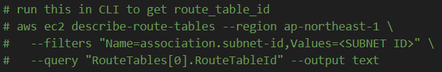
Why you used it: to find the rtb-... to plug into Terraform.

